2023
Internal Audit Department
Khalifa University
November - 2023


Internal Audit Report
Review of Continuing Education

Ref: KU/2023/IAD-145
November 2023

Dr. Yousof Alhammadi
Acting SVP Academic and Student Services
Khalifa University of Science and Technology

We have completed our review of the Continuing Education Activity. The review was conducted during September - October 2023 covering the period from January 2022 to March 2023.

The objective of our audit was to review the adequacy and effectiveness of internal controls system and Procedures; and to ensure compliance with operating Policies and Procedures, laws, regulations, and standards.

We have discussed the contents of our report, including our recommendations, with the respective processes’ owners and where relevant we have incorporated their comments and action plans to remediate our findings.

Yours Sincerely,

Abdulaziz Alkhoori
VP, Audit

Table of Contents

1. Executive Summary 4
1.1 Introduction 4
1.2 Scope of Work 4
1.3 Audit Objectives 4
1.4 Audit Process 4
1.5 Summary of Audit Findings 4
2. Background 4
3. Detailed Audit Findings 6
4. Appendices 14

- Executive Summary
  - Introduction
We have completed the Review of Continuing Education Activities, in line with the Approved Internal Audit Plan and Audit Engagement Memorandum of September 2023. The Internal Audit Findings / Improvement Opportunities to address associated risks / control gaps were identified and reported as part of this report.
  - Scope of Work
The Scope of Work comprised of the following areas:
- Governance and Compliance;
- Strategy;
- Key Performance Indicators (KPIs);
- Course Development and approval;
- Client Feedback;
- Course Registration;
- Course Allocation;
- Management Information system;
- Faculty Payment;
- Executive Courses; and
- Course Pricing.
  - Audit Objectives
The Objective of this review is to independently review the system of internal controls, level of compliance with Policies and Procedures, and the achievement of the desired objectives.
  - Audit Process
The following are the key Audit Steps undertaken by the Internal Audit Department:
- Gain an understanding of the processes of the areas covered in the scope listed above.
- Reviewed adequacy and effectiveness of internal controls system and procedures.
- Reviewed compliance with the policies and procedures, laws and regulations.
- Agreed with process owners on action plans to improve control effectiveness / process performance.
  - Summary of Audit Findings
Controls need to be enhanced for 0% of the observations. A balance of 87% is within the moderate range and 13% is within the low range and needs to be monitored and prevented from entering the high-risk category and moderate range as applicable.

Please refer to Appendix 1 for detailed Ratings
The audit findings observed during the review are summarized below. It should be noted that we have reported only on the exceptions detected during the course of our review.
- Background
Continuing Education Department was established in 2018 with the dual objectives of offering support to KU faculty and serving the UAE community through the provision of professional development and high-quality training programs designed to enhance skills in the fields of Science, Technology, and Engineering. The Department leverages the expertise of its faculty members to deliver professional development training, offering both short courses and training services to their strategic and external clients.

Continuing education and professional development courses are designed by faculty who are experts in their fields to provide recent graduates and experienced professionals with new knowledge, information, skills and opportunities to grow their careers, help advance their organizations, expand their network and impact their fields of profession. Participants are immersed in high quality learning opportunities and experiences that are both cutting-edge and practical. Instructors are often experienced professionals or subject matter experts in their respective fields. They bring practical knowledge and real-world experience to the classroom. The Department aims to create and sustain a positive and productive study and work environment that stimulates creativity and productivity and ensure a healthy and safe university for students, faculty and staff.

Program durations can vary, ranging from one-day workshops to several weeks, depending on the program's nature and the technical requirements of the clients. While most programs are held at Khalifa University, arrangements can be made for delivery at the client's location or other agreed-upon venues. Participants in these programs receive a certificate of attendance from Continuing Education. In certain cases, at the client's request, participants may also have the opportunity to undertake international professional examinations.

Continuing Education Main Topics
Continuing Education programs typically provide a diverse array of courses that span a broad spectrum of subjects, primarily focusing on the following areas:
- Communication Technology and Electronics.
- Material Development and Manufacturing.
- Medical.
- Artificial Intelligence.
- Energy (Oil and Gas).
- Cyber security.
- Advanced Technology and Security.
- Specialized Courses.

Continuing Education Main responsibilities
The main responsibilities of the Continuing Education Department, as outlined in the Policies & Procedures and discussed in Process Understanding sessions, can be summarized as follows:
- Develop, establish, and execute Continuing Education services to align with the University's goals.
- Articulate the strategic intentions, mission, and vision of the Continuing Education.
- Prepare the annual Continuing Education budget. Also, prepare the annual report for the Continuing Education.
- Formulate and implement Continuing Education policies and procedures.
- Assign faculty members to deliver training courses and manage their compensation/payment.
- Create the annual training plan and monitor its progress.
- Logistic and administrative aspects of training courses, including creating certificates for the training courses.
- Engage with clients to define terms and conditions for training contracts before course commencement. Also, Establish and nurture strong, successful partnerships with clients and potential clients.
- Provide guidance to faculty regarding their participation in Continuing Education initiatives.
- Collaborate with the finance department to address financial and accounting matters related to Continuing Education.
- Detailed Audit Findings

● Medium | - Policies and Procedures
Risk Ref: KU-CE-01
Observation/Process Enhancement
Our review of the Policies & Procedures document (2021) showed the following:
- Policies & Procedures are not approved in line with the DoA.
- Policies & Procedures document was last updated in 2021 with no subsequent updates or revisions, given that document does not capture the next review cycle.
In addition, there are inconsistencies / misalignment between the Policy & Procedures document's as follows:
- Policies & Procedures document defines two essential roles to oversee Continuing Education activities: a Continuing Education Director and a Continuing Education Business Development Manager. However, this is not aligned with the revised Organizational Structure which comprises only one position, "Continuing Education Manager".
- The title of the Form “Request to Engage in Continuing Education Activities-A1” has been revised to address further approval requirements. However, these changes have not been incorporated into the initial version of the form in the Policies & Procedures document.
Recommendation
Ensure periodic review / update of the Policies & Procedures document to address the emerging changes in the practices undertaken by the Function.
Management Action Plan:
As per the above recommendations.

Responsibility:
CE Management

Timelines:
31st December 2024

 Medium | - Organization Structure & Job Descriptions
Risk Ref: KU-CE-01
Observation/Process Enhancement
There are two distinct Organizational Structures as detailed below:
  - The outdated Organizational Structure, last revised in 2021, consisted of a separate function with two roles: Continuing Education Director and Continuing Education Specialist.
  - The revised Organizational Structure in 2023 included the CE function as a sub function within the CTL Department and consisted of a single position, Continuing Education Manager.
However, our review of the latest Organizational Structure and related Job Descriptions (JDs) showed the following:
The single position - Continuing Education Manager – as per the revised Organizational Structure is currently vacant given that the Continuing Education activities are being managed / administered by the following staff members (not on Org Chart):
- CTL Director – responsible for managing CE operations – reporting to Assistant Vice President, Student Affairs & Outreach
- Staff member seconded from the Emirates College of Advance Education (ECAE) handling administrative and operational tasks reporting to CTL Director.
- Business Development Manager and Business Development Specialist responsible for executing the marketing and payments tasks.
Further, our benchmarking practices showed that the Organizational Structure can be further enhanced in terms of comprehensiveness to include further positions roles that are vital for the success of Continuing Education including Marketing and Media Specialists, Program Coordinators, Business Development Manager and Specialist.
Finally, the corresponding Job Descriptions have not been made in documented and approved format outlining the roles and responsibilities assigned to staff members.
Refer to Appendix 2 (Organization Structure) for further details.
Recommendation
- Update the Organizational Structure to include the essential roles for Continuing Education.
- Develop and approve Job Descriptions for staff members to clarify their roles and responsibilities.
- Address the available vacancies in the updated Org Chart and provide clear management responsibilities for non-charted staff members.
Management Action Plan:
As per the above recommendations.

Responsibility:
CE Management

Timelines:
31st December 2024

 Medium | - Delegation of Authority Manual (DoA)
Risk Ref: KU-CE-01
Observation/Process Enhancement
The Delegation of Authority (DoA) lacks comprehensive coverage of specific approvals required for Continuing Education activities. Below are instances of operations requiring specific approvals that are not incorporated in the DoA:
- Faculty Compensation Pay Rates: although the rates were approved by Senior Vice President of Support Services and Director of Continuing Education, these approvals were not formally documented within the governance of CE.
- Training Course Cost and Prices: although the courses costing and pricing were approved by the Senior Vice President Support Services and Director of Continuing Education, these approvals were not formally documented within the governance of CE.
Recommendation
Update the Delegation of Authority (DoA) to ensure comprehensive coverage of specific approvals required for Continuing Education activities.
Management Action Plan:
To be reflected as per of the updated governance structure/documents.

Responsibility:
CE Management

Timelines:
31st December 2024

● Medium | - Training and Marketing Plans
Risk Ref: KU-CE-02 & KU-CE-07 & KU-CE-04
Observation/Process Enhancement
The existence of Annual Training Plan for Continuing Education programs supports ongoing professional development, with Market Studies and Marketing Plans being essential in assessing demand, ensuring efficient resource allocation, and bolstering course sustainability and financial stability.
During our review of the Training and Market Plan, we noted the following:
- Although the Annual Training Plan was developed for the year, the criteria and guidelines to support the development of the plan were not made in documented and approved format.
- While informal Market Plans and Studies were undertaken to cater to the demand for new courses and attract students and professionals to the training programs offered, the criteria and guidelines for these plans were not made in documented and approved format.
Recommendation
- Develop a Policy that encompasses documented criteria and guidelines for both the Annual Training Plan and Market Plans and Studies, ensuring formalization, consistency, and transparency in addressing the demand for new courses and attracting students and professionals to training programs.
- Implement mechanisms to ensure compliance with the newly established policy, including regular reviews and accountability measures to monitor adherence and effectiveness.
Management Action Plan:
To be reflected as per of the updated governance structure/documents.

Responsibility:
CE Management

Timelines:
31st December 2024

● Low | - Key Performance Indicators (KPIs)
Risk Ref: KU-CE-03 & KU-CE-11
Observation/Process Enhancement
KPIs for Continuing Education are not explicitly defined. Instead, data from the KU Annual Plan, reported to ADEO for the fiscal years 2022 and 2023, serve as the KPIs for Continuing Education, consisting of the following:
- Update the training schemes of the continuing education center.
- Increase numbers of fee-paying students.
- Secure more grants and funds from research projects.
- Establish partnership with wider range of national and international entities for consultation support.
The existing set of Key Performance Indicators (KPIs) mainly revolve around financial and revenue-related aspects, with limited coverage of the operational domain. The following suggested KPIs for a more comprehensive evaluation were not included:
- Student Satisfaction and Feedback;
- Program Completion and Success Rates;
- Marketing and Outreach Effectiveness;
- Faculty and Instructor Performance;
- Course and Program Development;
- Operational Efficiency;
- Market Research and Competitive Analysis;
- Innovation and Adaptation; and
- Lifelong Learning Impact.
Recommendation
Enhance the existing KPIs by including additional operational KPIs to provide a more comprehensive assessment beyond financial and revenue aspects (as listed above).
Management Action Plan:
To be reflected as per of the updated governance structure/documents.

Responsibility:
CE Management

Timelines:
31st December 2024

● Medium | - Training Certificates and Courses Registration
Risk Ref: KU-CE-05 & KU-CE-15 & KU-CE-10
Observation/Process Enhancement
During our review of the certification and registration Process, we noted the following:
- There is no automated system in place for the issuance of certificates, as certificates are currently generated manually.
- Certificates lack a QR code, which could offer benefits such as instant validation, improved data security, enhanced convenience, the collection of valuable data for analytics, and the provision of digital access.
- No documented process in place for online registration for Training Courses & Workshops.
Recommendation
- Implement an automated certificate issuance process that includes QR codes on certificates to enhance validation, data security, convenience, and analytics capabilities.
- Develop a procedure for online registration for Training Courses & Workshops to streamline the registration process and improve user experience.
- Exploring the possibility of developing training programs in Arabic, and incorporating bilingual faculty.
- Explore the possibility of increasing the offering of cost-free training courses.
Management Action Plan:
To be reflected as per of the updated governance structure/documents.

Responsibility:
CE Management

Timelines:
31st December 2024

● Medium | - Revenue & Satisfaction Survey
Risk Ref: KU-CE-06 & KU-C-CE-08
Observation/Process Enhancement
- Revenue Generation:
The 2022 annual report shows that Continuing Education generated a revenue of AED 4,664,125.27. Courses are instructed by KU faculty, whose availability as per the Policy allowing them to teach only 36 days per year.
However, during our review and discussion with CE Management, we noted the following:
- Continuing Education faces limitations due to resource shortages, impacting their capacity to broaden course offerings and explore additional partnerships and training opportunities.
- There is currently no record of online training courses accessible to students / professionals through a username and password for a defined duration, serving as a viable alternative to live courses. This approach has the potential to yield substantial cost savings and enable the provision of a greater number of courses throughout the year.
It's important to note that the CTL director mentioned that no such initiatives existed in 2022. However, they have recently launched a project called TDM using the Blackboard platform, which is presently in the testing phase. Blackboard is a widely adopted learning management system (LMS) utilized by numerous educational institutions for delivering online courses and overseeing course materials, assignments, discussions, and various virtual learning activities. It serves as a platform for instructors to develop, deliver, and evaluate online courses, while providing students with access to course materials and the opportunity to engage in online learning experiences."
- Designated Areas for Continuing Education
There are no designated specific areas allocated for conducting Continuing Education activities and training courses. Instead, the Marhaba Zone, Library, and Boardroom are reserved in advance for hosting these training sessions.
Recommendation
- Explore the possibility of allocating additional resources to Continuing Education to expand course offerings and explore new partnerships and training opportunities.
- Develop and implement a system for online training courses accessible via username and password, providing a cost-effective alternative to live courses and enabling more course offerings throughout the year.
- Explore the possibility of establishing dedicated areas for Continuing Education activities and training courses to improve operational efficiency and consistency.
Management Action Plan:
As per the above recommendations.

Responsibility:
CE Management

Timelines:
The management will take the necessary actions ASAP, with the aim of completing them by December 31, 2024, at the latest.

● Medium | - Faculty Payments & Outsourcing Contracts
Risk Ref: KU-CE-09 & KU-CE-14
Observation/Process Enhancement
      - Faculty Payments:
A Faculty Pay Rate Structure has been developed to determine the hourly compensation rate for faculty members instructing training courses, with the following breakdown:
- Standard Courses AED 300
- Advanced Courses AED 450
- Customized/Specialized Courses (Highly Profitable) AED 600
Our review of 5 samples - Faculty payment compensations showed the following:
- In 5 out of 5 samples, delays were encountered upon processing faculty payments whereby the related payments to services / training occurred in 2022 were made in 2023.
Refer to Appendix 3 (Faculty Payments) for further details.
      - Third Party Agreement:
In 2019, the Continuing Education Department entered into an agreement with the ECAE for project management and administrative support services including IT services related to Learning Management System (LMS) - Masary.
Our review of the compliance with Contract showed that Masary System has remained inactive and has not been employed in accordance with the signed contract, which was intended to offer learner registration, attendance tracking, satisfaction surveys, certificate generation, and billing services. Instead, all these tasks were manually conducted outside the system.
Recommendation
- Further, improve payment processing efficiency to prevent delays, ensuring that payments are made in the same year as the services or training occur.
- For Third Party Agreement, activate / fully utilize the Masary System in compliance with the signed contract, enabling streamlined processes for learner registration, attendance tracking, satisfaction surveys, certificate generation, and billing services as outlined in the agreement.
Management Action Plan:
For several reasons the Masary system can’t be customized, the CE function will contact legal to address this matter.

Responsibility:
CE Management

Timelines:
31st January 2024

Appendices

Appendix 1 - Findings Rating
The audit findings have been grouped together in a logical manner to appropriately convey the risk and impact. The audit findings have been categorized based on their criticality rating as High, Medium and Low. The definitions of the finding’s criticality / distribution are provided in the table below
 | Finding Rating | Definition | Number of Findings | Total
● | High | Finding is serious and deserves immediate attention by the Process Manager. The finding is reported to the Audit Committee quarterly. | 0 | 8
● | Medium | Finding impacts the accomplishment of the Process objectives. Corrective action is required by management. If not resolved, the finding could result in inefficient use of entity resources and or potentially disrupt business processes. | 7
● | Low | Finding to be reported to Management but is of a minor risk to the entity. Findings will not be reported to the Audit Committee unless the finding remains open after the follow up audit. | 1

Appendix 2 – Organization Structure

- 2021 Organization Structure
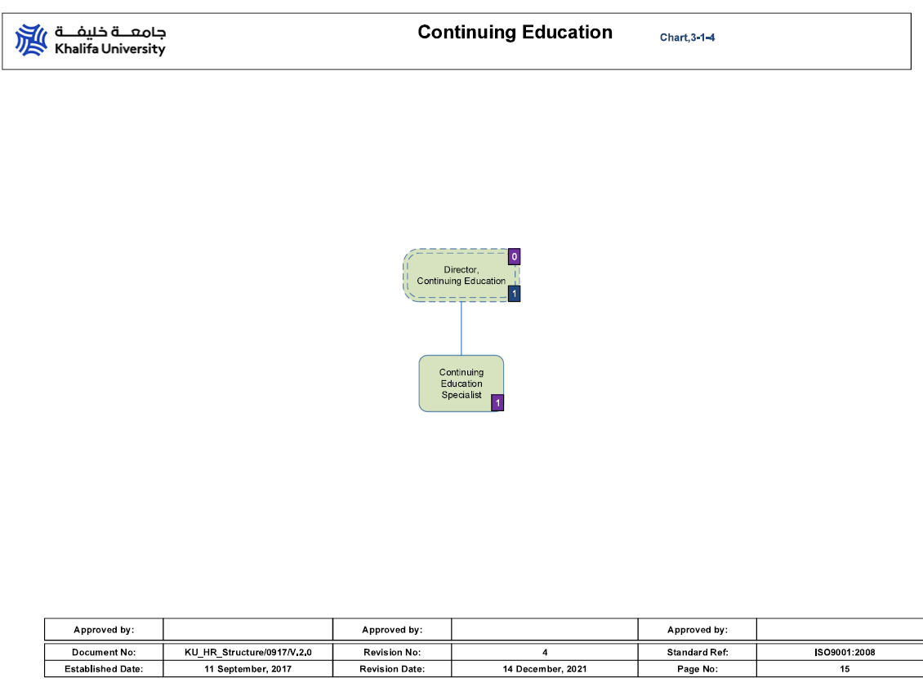

- 2023 Organization Structure
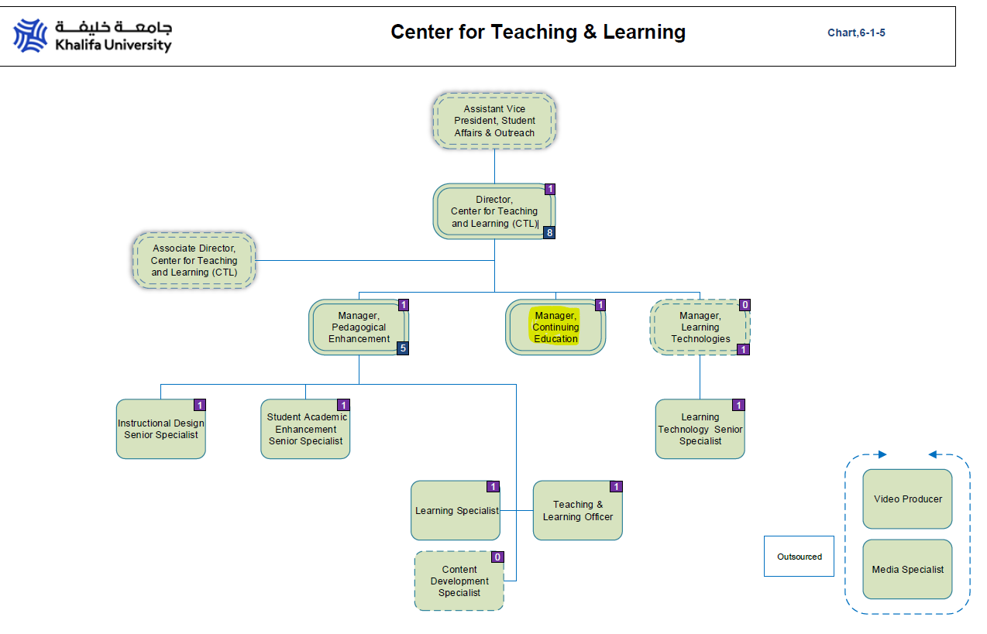

Appendix 3: Faculty Payments.

# | Course name | Course Category | No of Hours | Pay Rate - per hour – per Policy | Standard Payment - per Policy  (1) | Actual Paid to Faculty  (2) | Difference  (1-2) | Course End Date | PMR no. | Faculty Payment Date | No of Days to process Payments
1 | Clinical Research Certificate Training Program Cohort 1 &2 | Specialized | 34 | 600 | 20,400 | 20,400 | 0 | 30/04/2022 | PMR20225433 | 24/08/2022 | 117 days
2 | ADIA Bridge Program Phyton | Customized | 45 | 600 | 27,000 | 20,250 | -6,750 | 15/7/2022 | PMR20225603 | 7/12/2022 | 146 days
3 | Advanced Electronics (AD Police) | Standard | 40 | 300 | 12,000 | 12,000 | 0 | 4/11/2022 | PMR20237016​ | 8/3/2023 | 125 days
4 | Artificial Intelligence for Emergencies and Crises (NCEMA) | Standard | 24 | 300 | 7,200 | 7,200 | 0 | 28/10/2022 | PMR20237020​ | 8/3/2023 | 132 days
5 | Clinical Research Certificate Training Program Cohort 3 | Specialized | 3.63 | 600 | 2,178 | 2,178 | 0 | 31/12/2022 | PMR20237547 | 8/4/2023 | 99 days

